(Approx. 602 words)

Tips for Printing a PowerPoint Presentation
Nancy DeMarte, 1st Vice President, Sarasota Technology User Group, FL
September 2015 issue, Sarasota Technology Monitor
www.thestug.org
ndemarte (at) Verizon.net

Microsoft Office users can find many uses for the powerful presentation application, PowerPoint. In a matter of minutes, a person can create a decent, professional-looking series of slides for meetings, classes, special occasions, or trip memories. These can be projected on a screen or shared with others through the Internet. Sometimes the creator might have a reason to print the presentation slides. Ironically, it is easier to create a slide show with PowerPoint than it is to choose the appropriate settings for printing it. PowerPoint offers more options for printing than any other MS Office program.

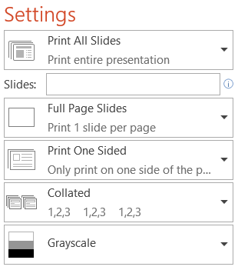
Why would a person want to print a presentation? If the slides contain a lot of informational text, as they might for a class or meeting, then the audience would certainly benefit from a copy to take home. In another scenario, an audience member might have missed the presentation and need to see what it contained. The presenter might want a copy for his or her files or one that includes notes.

What are the best printing options? The default option prints one copy of the entire show with each slide being Full Page size. Most of the time this is the worst choice. It uses an unnecessary amount of paper and a large amount of printer ink or toner. Let’s look at other choices.

If I am the presenter and want to distribute handouts to an audience, I have a choice of the number of slide thumbnails I want per page up to nine. When choosing the number of slides to print, I consider two things: how many pages do I need to distribute the slides evenly among the pages, and how important is it for the audience to be able to see the details on each slide, since fewer slides per page result in larger slide thumbnails.

If I want the audience to have room to take notes during the presentation, I often choose the three slide per page option, which prints thumbnails large enough to make details easy to read and includes lines next to each thumbnail for note taking. If the presentation is mainly text, then printing the text only Outline view might be enough for my audience. Besides, it saves paper by reducing the number of pages.

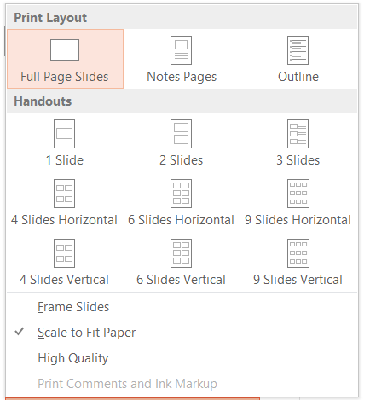
In several layouts with multiple slides per page, I must choose whether to display the slides horizontally or vertically. I most often choose horizontally because it is the common reading direction in English.

The presenter might select the Notes Page view for his or her own copy. This option prints a half page slide thumbnail on each page, as well as the notes the presenter has typed below each slide as he or she created the presentation.

Other print options include printing on one or both sides of the paper, collating the copies into complete sets of paper in order (1, 2, 3), and printing in color. Unless color is an important part of the presentation, such as a photo album, my advice is to choose one of the two non-color options – grayscale (black, gray, and white) or pure black and white. Ink is expensive.

Once I have customized the print options, I can save my changes in PowerPoint Options. Click File – Options – Advanced, and scroll down to “Print” to find specialized options related to print quality. Scroll further to the “When printing this document” section to save your current print settings for future printings on this presentation.

